Kit List
Wendy’s House

Dining
Sleeping
✅Beds
✅duvet
✅pillows
✅blankets
✅Battery lamp
❌spare batteries*
❌hot water bottle

❌Other stuff you might need

✅rugs
✅firepit
❌camping chairs
❌firewood*
❌firelighters*
❌matches*

First aid
❌Bug spray*
❌Plasters
❌After sun*

*Can be hired / purchased in our store

✅plates
✅bowls
✅cups
✅mugs
✅cutlery
✅picnic table
❌Tablecloth

Kitchen
✅sharp knife
✅peeler
✅wooden spoon
✅spatula
✅can opener
✅bottle opener / corkscrew
✅cutting board
❌Camping stove

Dishes:
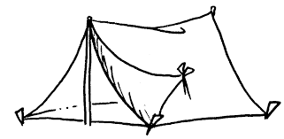
✅tea towel
✅washing up bowl

❌sponge
❌washing up liquid

Campfire
✅kettle
✅saucepan
✅frying pan
✅bbq tongs
❌grill*
We hope you will find the items we put in your tent useful and practical. Please let us know if there is anything else we may be able to provide.

